Big Flats Residential Water Cost Comparison Chart
Current Rates Used (passed 8/2022)
 | Price per Gallon | $1.00 Buys….
Big Flats Water District 5  $42.75/10,000 gals | $0.004 | 250 gallons
Big Flats Water District 4  $51.44/8,000 gals | $0.006 | 167 gallons
Milk | $2.99 | 0.33 gallons
Bottled water $5/case of 24-16.9 oz btls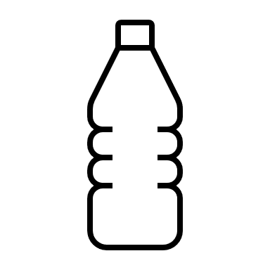 | $3.17 | 0.31 gallons
Soda, $1.75/2-liter bottle | $3.31 | 0.30 gallons
Gasoline 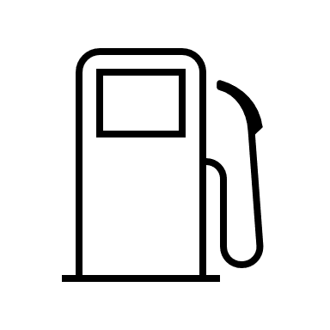 | $3.50 | 0.28 gallon
Wine, $12.00/750 ml bottle | $60.47 | 0.02 gallons

